Talen Phillips

Dustin Maclay

Lab 7: Serial to Seven Segment Display

05MAR2013

**Introduction**

In this lab, students were asked to use an Arduino microcontroller to operate a seven segment display. Students were asked to use the digital IO pins on the Arduino unit to drive each segment individually, and write software that allowed manipulation of the display via the serial interface. The display should output whatever number is entered into the serial interface.

**Procedure**

First, the students determined that the display was common anode, and wired it so that each digital IO pin from pin 1 to pin 7 was connected to the pin on the display corresponding to a particular segment. Then the students connected the common anode pin to ground through a resistor box set to 190 ohms (this resistance was adjusted later).

Since pin 1 is part of the serial interface for the Arduino, the corresponding LED segment remained lit permanently while connected. The students rectified this by switching the connection to pin 9, and altering the software to compensate. Because the pins were defined at the top of the Arduino sketch, it was extremely simple to adjust the program.

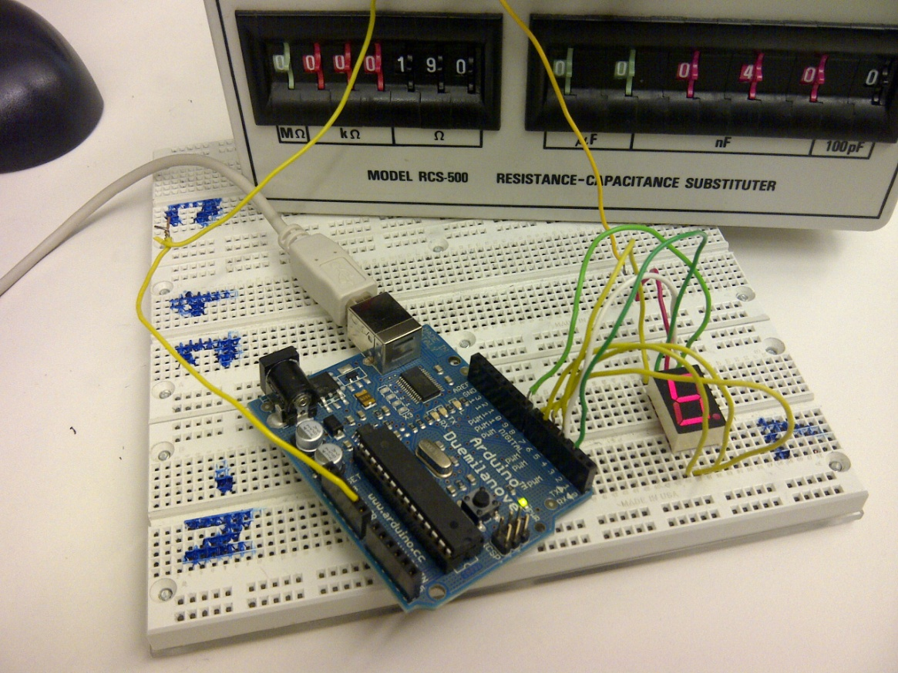

The code that was used to run the system was as follows:

/* Talen Phillips and Dustin Maclay

* EE107-01

* 05MAR2013

* "Arduino seven segment controller"

*/

int in; // input from incoming serial data

int led1=8;

int led2=2;

int led3=3;

int led4=4;

int led5=5;

int led6=6;

int led7=7;

void setup()

{

Serial.begin(9600); // opens serial port, sets data rate to 9600 bps

pinMode(led1, OUTPUT);

pinMode(led2, OUTPUT);

pinMode(led3, OUTPUT);

pinMode(led4, OUTPUT);

pinMode(led5, OUTPUT);

pinMode(led6, OUTPUT);

pinMode(led7, OUTPUT);

}

void loop() {

// send data only when you receive data:

while (!Serial.available());

// read the incoming byte:

in = Serial.read();

if (in == '0') //set each segment to display the number ‘0’

{

digitalWrite(led1, HIGH);

digitalWrite(led2, HIGH);

digitalWrite(led3, HIGH);

digitalWrite(led4, LOW);

digitalWrite(led5, HIGH);

digitalWrite(led6, HIGH);

digitalWrite(led7, HIGH);

}

if (in == '1') //set each segment to display the number ‘1’

{

digitalWrite(led1, LOW);

digitalWrite(led2, LOW);

digitalWrite(led3, HIGH);

digitalWrite(led4, LOW);

digitalWrite(led5, LOW);

digitalWrite(led6, HIGH);

digitalWrite(led7, LOW);

}

if (in == '2') //set each segment to display the number ‘2’

{

digitalWrite(led1, HIGH);

digitalWrite(led2, LOW);

digitalWrite(led3, HIGH);

digitalWrite(led4, HIGH);

digitalWrite(led5, HIGH);

digitalWrite(led6, LOW);

digitalWrite(led7, HIGH);

}

if (in == '3') //set each segment to display the number ‘3’

{

digitalWrite(led1, HIGH);

digitalWrite(led2, LOW);

digitalWrite(led3, HIGH);

digitalWrite(led4, HIGH);

digitalWrite(led5, LOW);

digitalWrite(led6, HIGH);

digitalWrite(led7, HIGH);

}

if (in == '4') //set each segment to display the number ‘4’

{

digitalWrite(led1, LOW);

digitalWrite(led2, HIGH);

digitalWrite(led3, HIGH);

digitalWrite(led4, HIGH);

digitalWrite(led5, LOW);

digitalWrite(led6, HIGH);

digitalWrite(led7, LOW);

}

if (in == '5') //set each segment to display the number ‘5’

{

digitalWrite(led1, HIGH);

digitalWrite(led2, HIGH);

digitalWrite(led3, LOW);

digitalWrite(led4, HIGH);

digitalWrite(led5, LOW);

digitalWrite(led6, HIGH);

digitalWrite(led7, HIGH);

}

if (in == '6') //set each segment to display the number ‘6’

{

digitalWrite(led1, HIGH);

digitalWrite(led2, HIGH);

digitalWrite(led3, LOW);

digitalWrite(led4, HIGH);

digitalWrite(led5, HIGH);

digitalWrite(led6, HIGH);

digitalWrite(led7, HIGH);

}

if (in == '7') //set each segment to display the number ‘7’

{

digitalWrite(led1, HIGH);

digitalWrite(led2, LOW);

digitalWrite(led3, HIGH);

digitalWrite(led4, LOW);

digitalWrite(led5, LOW);

digitalWrite(led6, HIGH);

digitalWrite(led7, LOW);

}

if (in == '8') //set each segment to display the number ‘8’

{

digitalWrite(led1, HIGH);

digitalWrite(led2, HIGH);

digitalWrite(led3, HIGH);

digitalWrite(led4, HIGH);

digitalWrite(led5, HIGH);

digitalWrite(led6, HIGH);

digitalWrite(led7, HIGH);

}

if (in == '9') //set each segment to display the number ‘9’

{

digitalWrite(led1, HIGH);

digitalWrite(led2, HIGH);

digitalWrite(led3, HIGH);

digitalWrite(led4, HIGH);

digitalWrite(led5, LOW);

digitalWrite(led6, HIGH);

digitalWrite(led7, HIGH);

}

}

Please note that the lab assistant recommended code that utilized a switch case function with a separate case for each number. The series of IF statements accomplishes the same goal with a similar amount of source text, and is at least as easy to read. Either method seems perfectly acceptable, however.

**Conclusion**

In this lab, the students learned how to use the Arduino microcontroller to interface with, and drive a seven segment display. This is important, since this is a very common type of application for a microcontroller. This particular group also ran into an issue which demonstrated the value of the global pin definitions that are recommended best practices at the beginning of each sketch. We were able to modify the program almost instantly when a problem arose.